**Sentinel Policy in GCP Terraform**

**Create and test the sentinel policy in GCP, to check the machine type of VMs from terraform cloud**

1.Created sentinel.hcl file

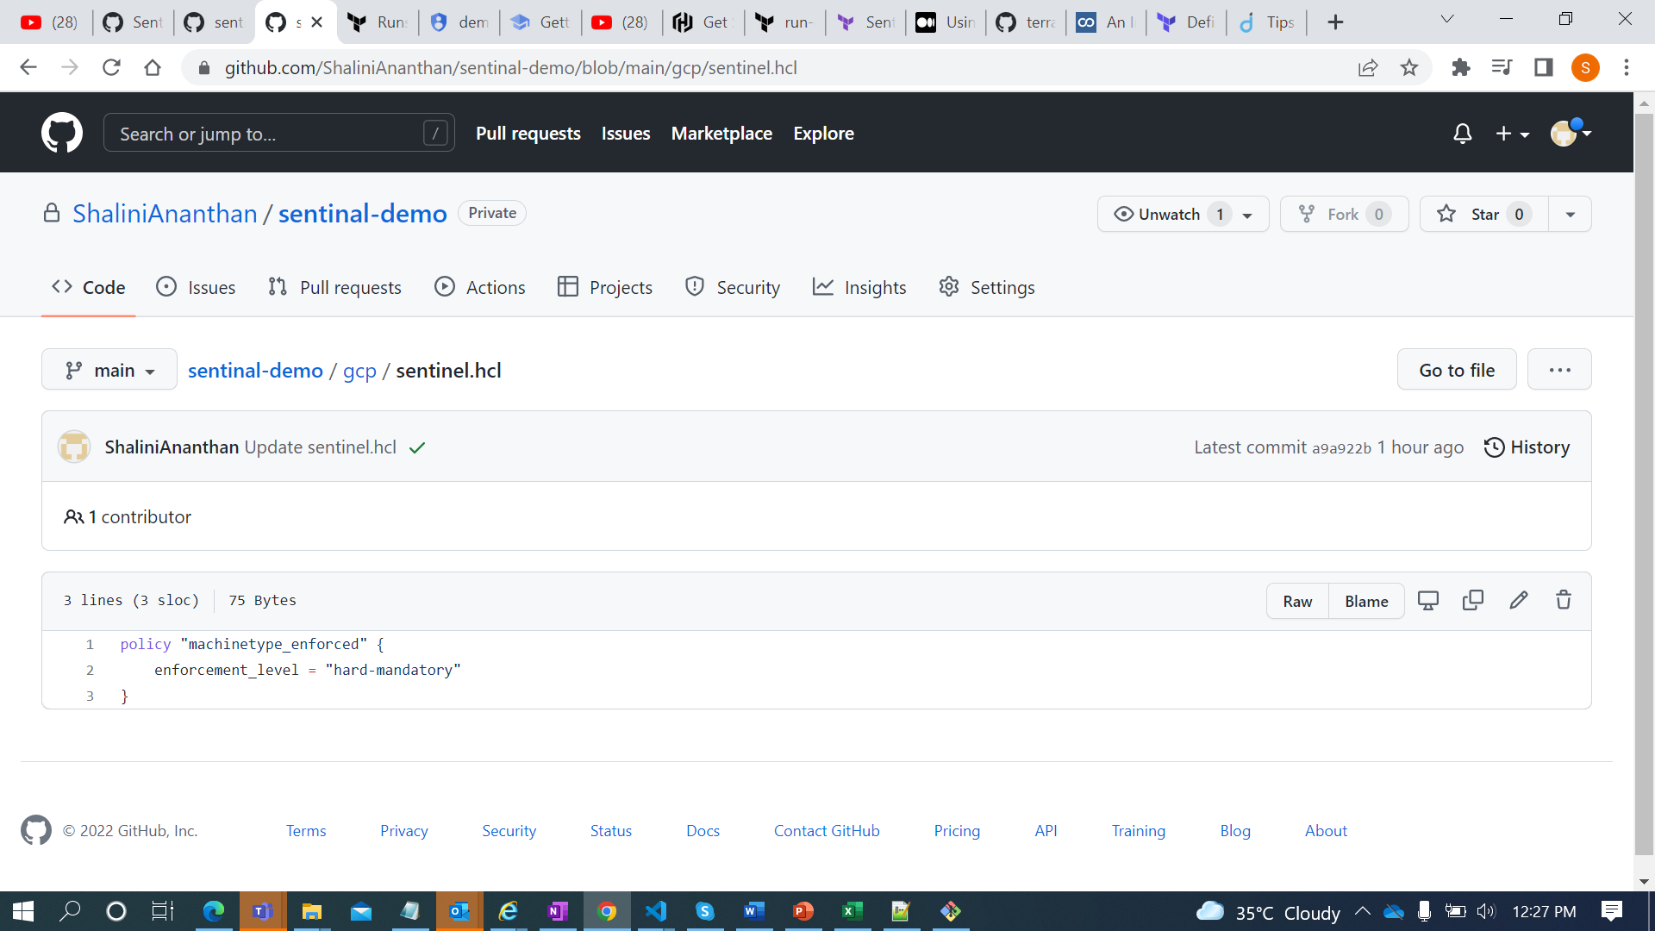

2.Created another file called machinetype_enforced.sentinal which will check the machine type of VMs.

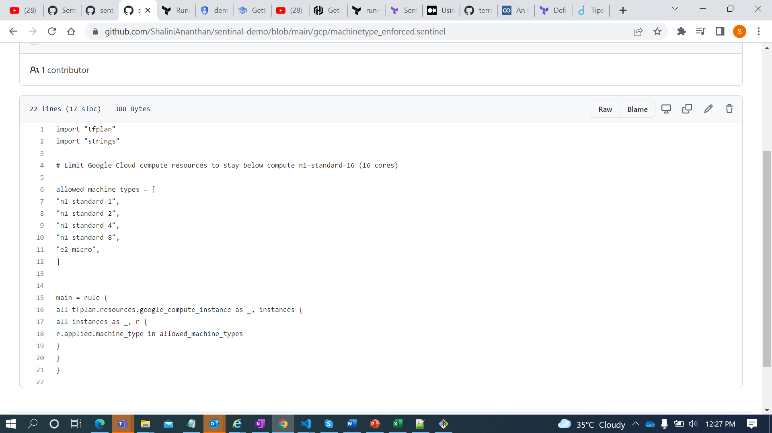

3.Created the policy sets in terraform cloud and added the git repo respectively.

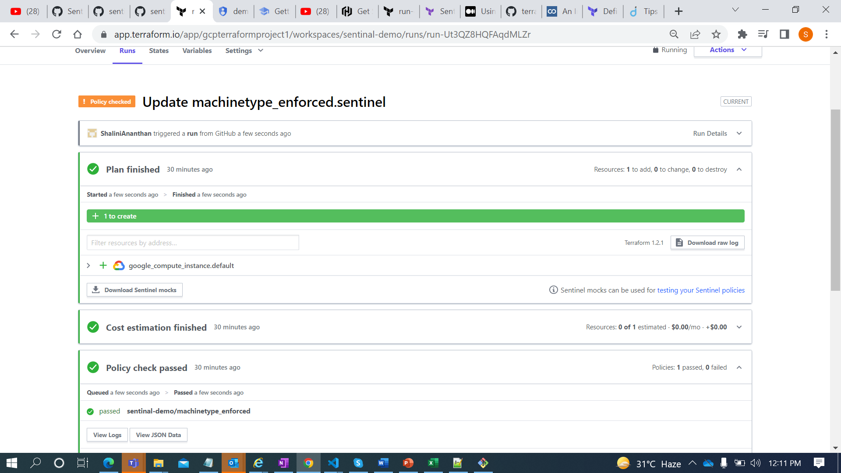

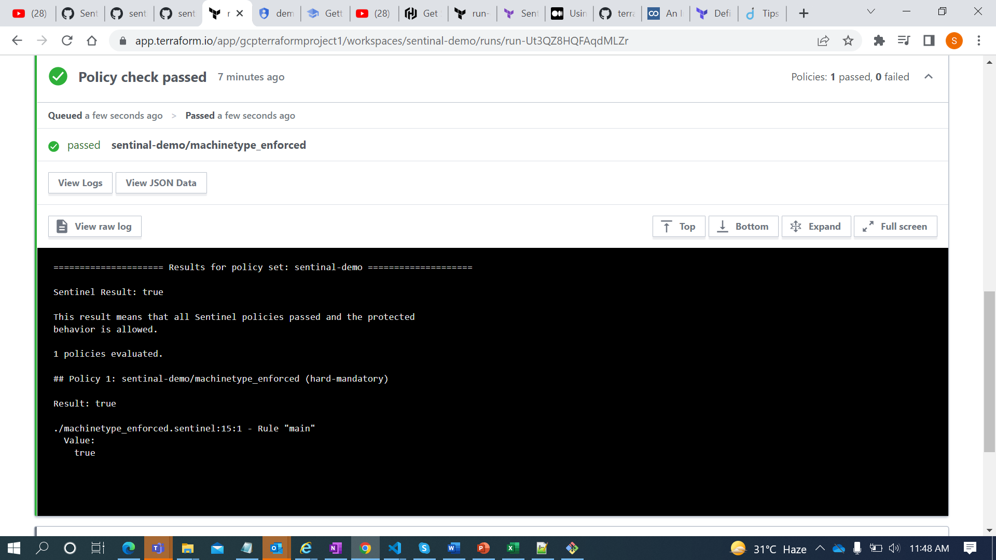

4.Removed the machine type and tested the policy.

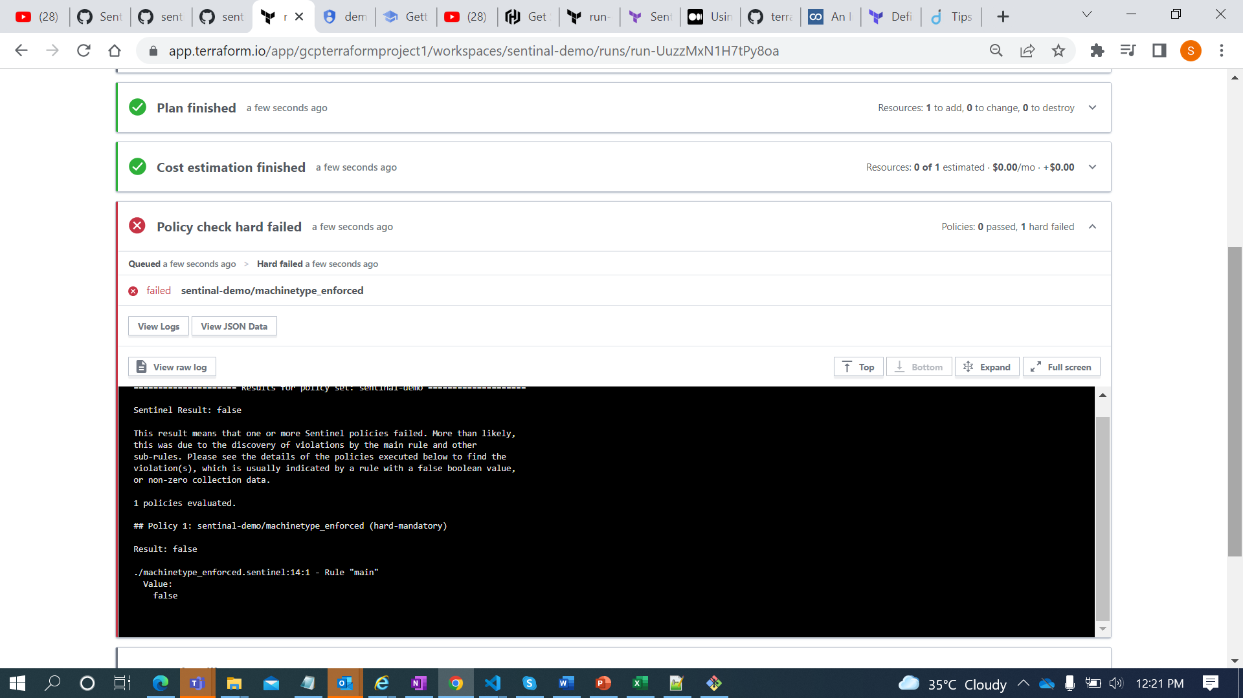

Result :

Created and tested simple sentinel policy in gcp to check the machine type of VMs